JAVA MINI PROJECT
Name: Urwashi Dhawas
Prn: 24070521154
Sem: 4th C
Topic: Student Management System

1. Student Management System
Design a Java program that demonstrates inheritance by creating a hierarchy of classes (Person, Student, and GraduateStudent) to store and display complete student details.
Develop a Java program to illustrate the concept of inheritance by handling student information. Begin by creating a base class called Person that includes common attributes such as name and age. Next, define a derived class Student that extends the Person class and incorporates additional properties like roll number and marks. Further, create another subclass named GraduateStudent that inherits from Student and adds a field for specialization. The program should ultimately display complete details of a graduate student by making use of the inherited attributes from all parent classes.
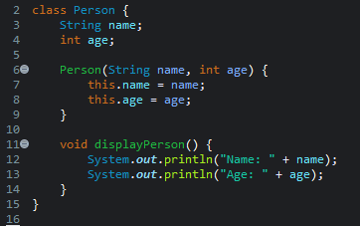
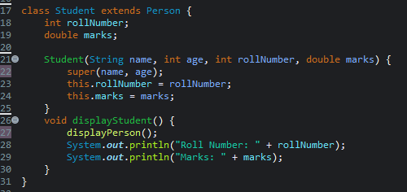
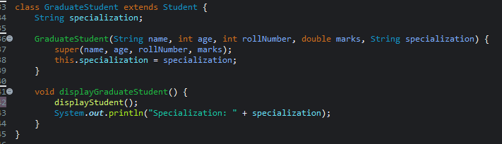

OUTPUT:
